Executive Kids
September 2020 Camp

Due to the late start in the 2020-2021 Verona school year, Executive Kids will offer care for any families. Below is some information about our program. For more information and registration, please email Alecia Rella, Director of Executive Kids Brookdale Campus at aleciaexecutivekids@gmail.com.

Location:
Brookdale Elementary School
14 Brookdale Court, Verona
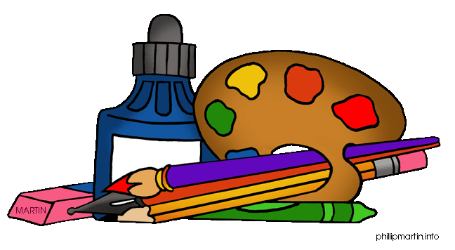
Hours:
7:00am to 6:30pm
Monday through Friday

Dates:
August 31, 2020 to September 4, 2020
September 8, 2020 to September 11, 2020

Prices:
$50.00 a day
$230.00 a week

Ages:
PK through 4th grade
*Can accommodate ages up to 13 years old

Space is limited! There is a $50.00 registration fee to secure your child’s enrollment. This will be due by June 1, 2020. Tuition for camp is due August 15, 2020. Payments must be by cash, check, or Venmo. Our Venmo name is @executivekids. Once the registration fee is paid, a registration form will be emailed to you for completion. Thank you and please let me know if you have any questions.
Please see reverse side for our daily camp schedule.

Time | Monday | Tuesday | Wednesday | Thursday | Friday
7:00-9:00 | Drop Off and Free Play | Drop Off and Free Play | Drop Off and Free Play | Drop Off and Free Play | Drop Off and Free Play
9:00-10:00 | Weekly Theme | Weekly Theme | Weekly Theme | Weekly Theme | Weekly Theme
10:00-10:30 | Snack | Snack | Snack | Snack | Snack
10:30-12:00 | Building | Cooking | Dance & Gymnastics | Entrepreneurship | Yoga & Exercise
12:00-1:00 | Outdoors | Outdoors | Outdoors | Outdoors | Outdoors
1:00-1:30 | Lunch | Lunch | Lunch | Lunch | Lunch
1:30-2:00 | Technology | Technology | Technology | Technology | Technology
2:00-3:00 | Arts and Crafts | Arts and Crafts | Arts and Crafts | Arts and Crafts | Arts and Crafts
3:00-3:30 | Snack | Snack | Snack | Snack | Snack
3:30-4:30 | Experiments | Pottery | Sports | Entrepreneurship | Free Play and Pick Up
4:30-6:30 | Free Play and Pick Up | Free Play and Pick Up | Free Play and Pick Up | Free Play and Pick Up
Daily Camp Schedule

